1. WHAT: is Python
   1. <https://www.youtube.com/watch?v=Hn4FbT4wMms>
   2. <https://www.youtube.com/watch?v=aXKVOLwpDg8>
   3. <https://www.youtube.com/watch?v=l9v1ewQXv5M>
2. WHY to use python:
   1. <https://www.youtube.com/watch?v=G8brQdClo9s>
   2. <https://www.youtube.com/watch?v=d5h79fTi65I>
   3. <https://www.youtube.com/watch?v=nh_BI2euMTM>
   4. <https://www.youtube.com/watch?v=GS84YRHhr_g>
   5. <https://www.youtube.com/watch?v=3yaIOsjiSm0>
   6. <https://www.youtube.com/watch?v=2i8ZqL99Vz0>
   7. <https://www.youtube.com/watch?v=ThS4juptJjQ>
   8. <https://www.youtube.com/watch?v=Iqjy9UqKKuo>
3. HOW: is python used and start with.
   1. Download Winpython IDE (Integrated development environment)
   2. https://sourceforge.net/projects/winpython/files/WinPython_3.5/3.5.2.2/
   3. It's a rar file, extract it at C drive and the folder shall be named as 'WinPython-32bit-3.4.4.2'.
   4. You will find something like this.

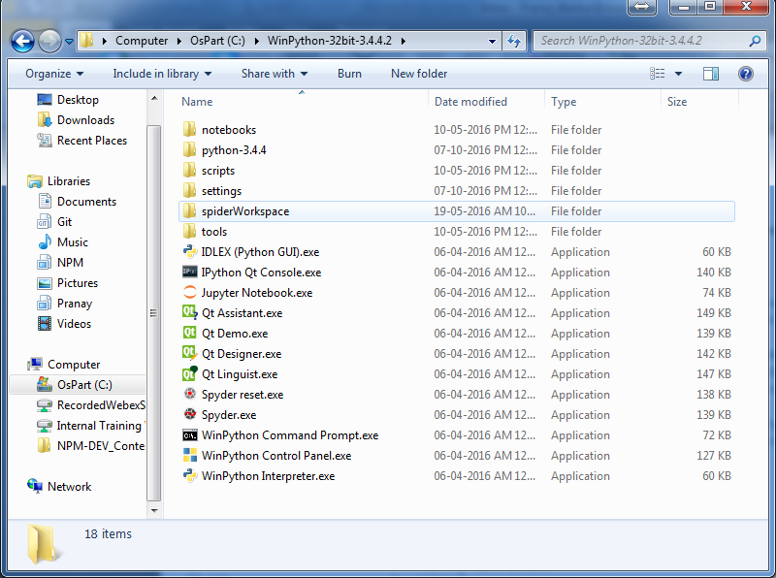

* 1. Open the Spyder.exe (I’ll explain the other files later)
     1. https://www.youtube.com/watch?v=dX2-V2BocqQ

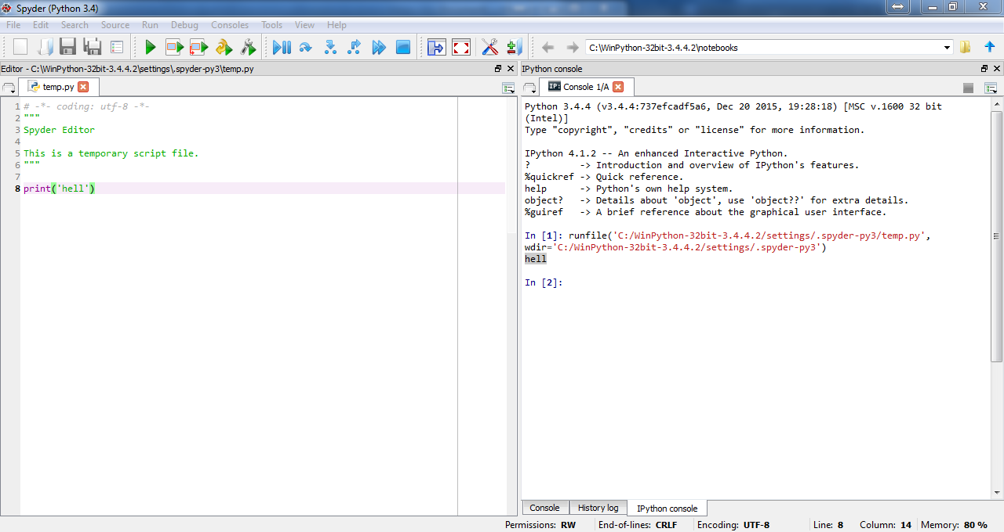

This is a console window where the result ‘hell’ will be displayed.

Click the green button of F5 button to run the code

Just a print command will do.

* 1. Now try some from the below links:
     1. <https://www.youtube.com/watch?v=cpPG0bKHYKc>
     2. <https://www.youtube.com/watch?v=aIPqt-OdmS0>
     3. <https://www.youtube.com/watch?v=twRQNSFXiYs>
     4. <https://www.youtube.com/watch?v=1X7gIsxXTt8>
     5. <https://www.youtube.com/watch?v=k3VoLjGA6jI>
  2. To learn from test follow:
     1. <http://www.tutorialspoint.com/python3/>